No. 2 Hydro House

i. General

No. 2 Hydro House is a structure designed and built by Ian Lindsay, Architect, in circa 1952. Nigel Campbell recalls working on this house as a young man; Mrs Noble attended the ceremony of laying the foundation stone. It was first occupied in 1954. It forms the central house of a group of three, the first of which is No. 1 Hydro House and the third of which is the Schoolhouse. These buildings are all of an extremely similar, almost identical detail. The Keenan’s bought No. 2 in 2006 and moved in on the 2nd of November; in 2007 they put in new bathroom and kitchen units.

Hydro Houses No. 1 and 2 are accessed by means of a stone stair that rises directly off the side of the village street. The front of the stair follows the line of the stone retaining dyke and consists of a single step up to a concrete base; from this rises up a straight flights of stairs, in a pair to east and west respectively. There is a quarter landing after seven steps and each one then angles up to the south with a further single flight of five steps. The stair itself is of rubble construction. The treads are formed of squared, coarsely-squared off slabs of schist. The walls are of rounded granite and other field or beach stone. There are handrails of wrought iron with simple arts and crafts detailing.

No. 2 is in many respects the better preserved one, retaining as it does its original fenestration and woodwork. These buildings are simply and handsomely designed in a traditional Scots idiom. Each is of 1.5 storeys aligned east/west and with their principal frontages facing the loch to the north. They sit upon rising ground above the village street in Cairndow and are located above a substantial drystone retaining wall with a sloping lawn area in front. Each has been slightly terraced back into the ground beyond to the south. No. 2 in particular has a very steeply, double pitched slated roof, set to diminishing courses. There is a single chimney in the west gable wall. The east gable wall of each of these houses had never had a chimney.
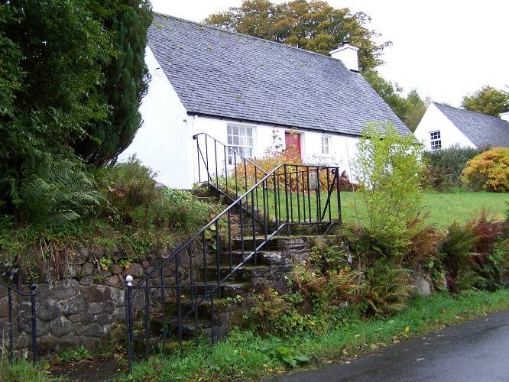
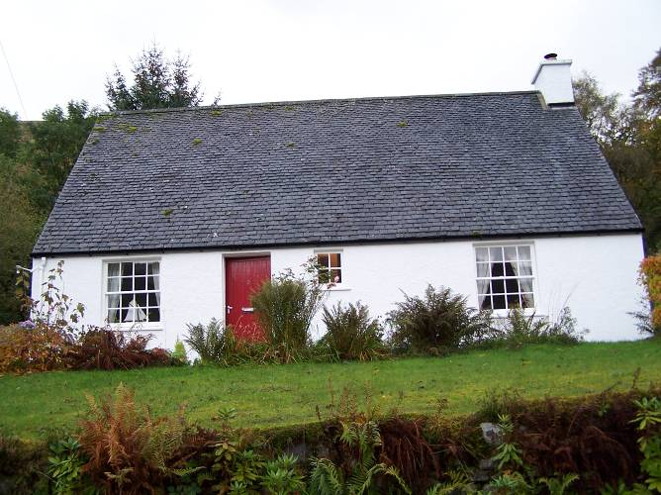

Figure 23 and 24 – street elevation with stair access (left), main street view (right).

ii. External elevations

Externally the building is harled and painted white. Overall the building is of three bays width although this is somewhat irregular. To either side are substantial sash-and-case windows, arranged eight-over-eight, and between them an entrance that is offset considerably to the east. Just a little on the west side of this entrance is a small stair window, of a fixed frame of four panes. The east gable wall has a single central first floor window. This is sash-and-case six-over-six.

The rear elevation at ground floor level is symmetrically arranged. Here there are entrances to the east and west and between these paired windows, sash-and-case six-over-six and a small centrally set window, evidently for a pantry because it has a fly mesh within it. It is on the rear pitch only where there are dormer windows. There are two dormer windows and these contain sash-and-case six-over-six. The roofs of the dormers are catslide, slated and the flanks of each dormer are also slated. There is also one small skylight.

Each of the window cills is a very narrow slab of cast concrete. All the window glazing bars are of fillet-and-ovolo profile and the panes are square. The three doors are framed and have a boarded panel containing tongue-and-grooved v-section boards. The west gable wall contains a window at ground floor level offset to the north and at first floor level a single window, again slightly offset to the north. Both of these are of six-over-six sash-and-case.

Backed into the hillside and the sunken area around the house is bounded by stone built retaining walls. Around the perimeter is a gravelled area and paths formed of concrete slabwork. The gravelled margin runs up to the wallfoot of the house although along the principal frontage, north facing, there is a border formed of vertical concrete slabs and a path crossing this to the principal entrance. The threshold of the principal entrance is formed of a single slab of slate. This is one step up from the path. The door within the principal entrance retains its original letterbox which appears to be of cast iron with a lustre finish. Rainwater goods are cast iron although the gutters themselves have been replaced in PVC.

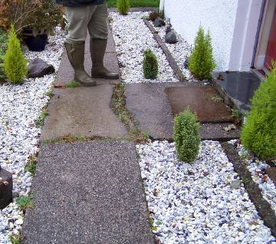
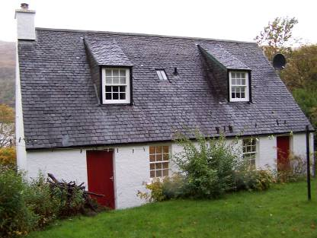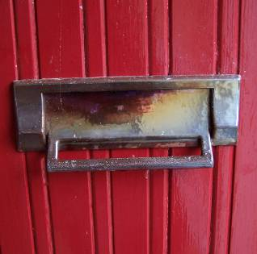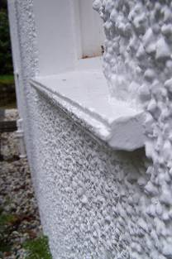
Figure 25, 26, 27 and 28 – external details: rear / garden elevation (far left), letterbox (centre left), sill detail at rear window (centre right), pavement slabs and gravelled area in front of main entrance (far right).

iii. Interior

The principal entrance gives into a small vestibule which has a tiled floor of 9” quarry tiles; this is now painted red. The cottage is sub-divided internally by walls that appear to be of solid construction, whether brick or blockwork it is unclear; the walls are plastered. The interiors are simply appointed with skirtings detailed with a rounded angle, and architraves around entrances with narrow rounded angles as well. The doors generally are panelled, four panelled doors throughout. The panel edge is detailed with an ovolo moulding. The original door furniture survives; the door handles appear to be of ebony with brass trim and the keyholes area covered by a rotating wooden, turned plate, probably also of ebony but now painted.

The vestibule leads into a hall area. The door into which is four panelled, the upper panel of which is glazed. The glazed panel in the door is of textured patterned glass. The interior is very neatly planned, arranged around the entrance hall area. This gives access to all of the ground floor rooms and spaces.

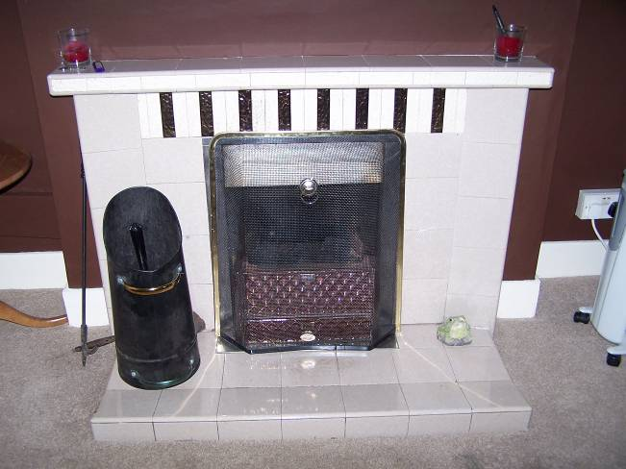
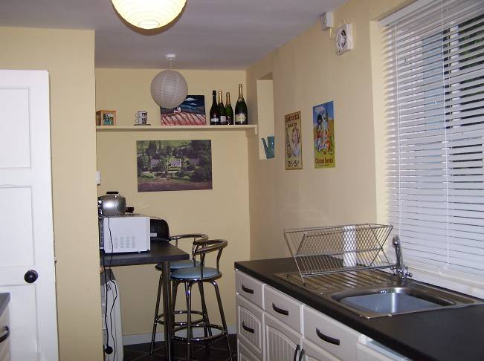
Figure 29 and 30 – kitchen from W end (left), fireplace in S wall of living room (right).

To the east, occupying the north-east corner of the house is the dining room; this with a window to the north overlooking the loch. In its south wall there are two doors providing access to presses. On the south side of the hall are three entrances.

The entrance to the south-east leads into a bathroom with a single window overlooking the garden to the rear. The interior of the bathroom is modern with white ceramic, bath, sink and toilet installed towards the end of 2007. The chrome towel rail on the west wall appears to be quite early. The existing tiled floor is of the more recent fit-out date.

The central entrance off the hall leads to a small coat closet.

The entrance to the north-east leads into the kitchen. The kitchen interiors are modern and have also been installed in the recent refurbishment including the floor. The back door is the original. An entrance within the kitchen to the west leads into a utility room and laundry area which has no natural lighting. At the west end of the south wall there is also an original kitchen press cupboard. A further recessed area, at the south-east part of the kitchen sits evidently where a partition wall has been removed; some scarring is visible. Clearly there had been a door into this area. This had been a small cold room or pantry. The window which is boarded over now can be seen externally with its flymesh.

The utility room at the west end of the kitchen appears to have been the original boiler room. There is an iron support at the north-west corner and behind this the external wall of the building is exposed. This wall is built of cement blockwork. The concrete blocks were apparently made locally, machine-pressed and ready-to-built. The western end of the kitchen interior, as it is now, had formerly been partitioned off and there had been a small rear entrance vestibule. The partition wall is now removed and the interior opened up. There are many early electric fittings that appear to be original to the place, including the doorbell, the bell of which appears in the kitchen on its north wall.

To the north of the hall is an entrance into the main living room. This is lit by windows to the north-west and a broader one to the north. Towards the south end of the west wall there is a projecting chimneybreast and the fireplace within appears to be the original. This is of beige, brown and cream tiles, predominantly of pale beige and has a cast iron fire within, this with a lustre glazed finish. All the detailing appears to be original. The cornice in this room is of ogee profile but is of recent installation. The floors throughout are of “suspended concrete construction” and are solid.

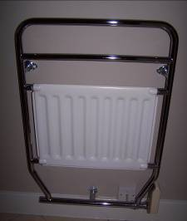
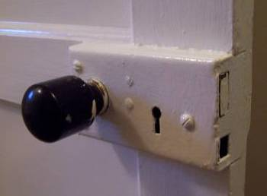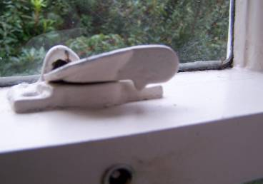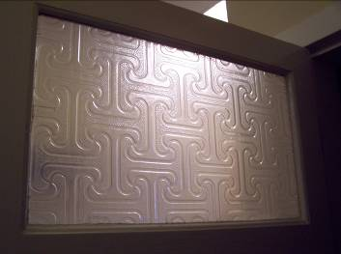
Figure 31, 32, 33 and 34 – internal details: door handle and lock of door to dining room (far left), window lock in living room , W window (centre left), ornamental glass in main entrance door (centre right), heating rail in bathroom, ca. 1950s (far right).

The north-west part of the entrance hall area is where the stair is located and beneath this is an understair, shelved cupboard. The stair rises up to the north in a short flight of four steps, running up to a half landing and returning back up to the south in a straight flight to the first floor level. The upper flight has a wooden handrail on its west side. The skirtings in this area are surmounted by a small ovolo moulding.

The stair rises up to a landing lit by a small cast iron skylight providing access to bedrooms to east and west. Each of these are high ceilinged with a slight coombing to the north and south. The western bedroom retains a fireplace which is built of small fire bricks with a wooden overmantel shelf. The small cast grate within has a lustred finish. The eastern room has no fireplace. These upstairs rooms have similar woodwork detailing than at ground floor, simple skirtings and architraves etc. The doors are of identical form to downstairs. Windows have brass furniture including the sash lock and the sash lifts. With the exception of the drawing room downstairs, the main living room, none of the rooms are corniced. All have plain plaster ceilings.

